केद्रीय विद्यालय रानीखेत
Periodic Test-2 Class-12 Mathematics
TIME: 90 Min M.M.:40
General Instructions: All questions are compulsory.

Q.No. | SECTION-A(1 Mark each) | Marks
 | Find the value of $\cos\left[\tan^{-1}\left\{\cot\left({(sin}^{-1}{\frac{1}{2})}\right)\right\}\right]$. | 1
 | If $\tan\left(\frac{x+y}{x-y}\right)=k , then find \frac{dy}{dx} .$ | 1
 | Find the area bounded by the curve $y=sinx$ and the x-axis between $x=0 and x=2π$. | 1
 | ASSERTION:$\int{e^{x}\left(cosx-sinx \right)dx= e^{x}\cos{x+c }}$  REASON:$\int{e^{x}\left(f\left(x\right)+f^{'}\left(x\right)\right)dx=e^{x}f\left(x\right)+c}$  - Both A and R are true and R is correct explanation of A  - Both A and R are true and R is not correct explanation of A  - A is true but R is false  - A is false but R is true | 1
Q.No. | SECTION-B (2 Mark each) | Marks
 | Find the differential of $\sin^{2}x w.r.t. e^{\cos{x }}.$ | 2
 | Find ‘a ‘and ‘b ‘, if the function given by $f\left(x\right)= \left\{\begin{aligned}ax^{2}+b , if x<1 \\ 2x+1 , if x≥1\end{aligned}\right.$ is differentiable at x=1. | 2
 | A man of height 2 metres walks at a uniform speed of 6 km/h away from a lamp post which is 6 metres high. Find the rate at which the length of his shadow increases. | 2
 | Find the value of $\int_{0}^{1}{x}{(1-x)}^{n}dx$ | 2
Q.No. | SECTION-C(3 Mark each) | Marks
 | If $y=\tan{x+\sec{x}}$, then prove that $\frac{d^{2}y}{dx^{2}}=\frac{\cos{x}}{{\left(1-\sin{x}\right)}^{2}}$ | 3
 | Let A = {a, b, c} and the relation R be defined on A as follows R = {(a ,a ), ( b,c ), (a , b)} Then, write minimum number of ordered pairs to be added in R to make R reflexive and transitive. | 3
 | Find $A^{-1}$of the matrix, A = $\left[\begin{matrix}1 & -1 & 1 \\ 2 & 1 & -3 \\ 1 & 1 & 1\end{matrix}\right]$ and hence solve the system of linear equations  x + 2y + z = 4 ; -x + y + z = 0 ; x – 3y + z = 2 | 3
 | Find the intervals in which the function f(x) = sin x + cos x, for 0$≤x≤$ 2 $π$ ,is increasing and decreasing. | 3
 | Evaluate: $\int{\frac{sin⁡x}{(1-\cos{x)}(2-\cos{x})}}dx$ | 3
Q.No. | SECTION-D (5 Mark each) | Marks
 | Evaluate $\int_{0}^{\frac{π}{2}}{\frac{x\sin{x\cos{x }}}{\sin^{4}x+\cos^{4}x}}$dx  OR  Evaluate $\int_{0}^{\frac{π}{2}}{[\log{\sin{x-log⁡(2\cos{x)] dx }}}}$ | 5
 | CASE STUDY
 | In order to set up a rain water harvesting system, a tank to collect rain water is to be dug. The tank should have a square base and a capacity of $250 m^{3}$ The cost of land is 5000 per square meter. The cost of digging increases with depth & for the whole tank, it is 40,000 h², where h is the depth of tank in metres and x is the side of the square base of the tank in metres.  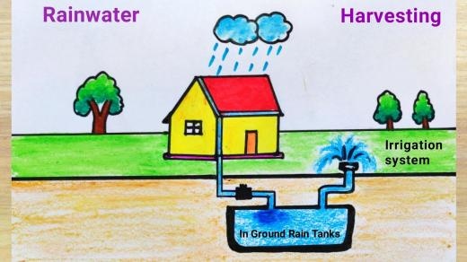  Answer the following from the above passage:  - Find the total cost C of digging the tank in terms of x.  - Find $\frac{dC}{dx}$  - Find the value of x for which cost C is minimum  OR  Check whether the Cost Function is increasing or not where x$>0.$ | 1  1  2
 | A child cuts a pizza with a knife. Pizza is circular in shape which is represented by $x^{2}+y^{2}=4$ and sharp edges of the knife represents a straight line given by $x=\sqrt{3} y$.  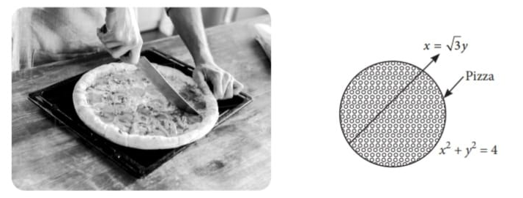  Based on the above information answer the following questions  (i) Find the point of intersection of line and pizza as shown in the figure.  (ii) Write the expression for the area bounded by the circular pizza and the edge of the knife in the first quadrant.  (iii) Find the area of the region bounded by the circular pizza and the edge of the knife in the first quadrant. | 1  1  2

